Sangala Mosaic User Guide
A Tool for Designing Mosaics in Tiles, Dots, or Beads

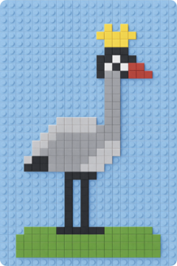
Table of Contents
1. The screen 1
2. The palette 1
3. Open a photo (and build a scene) 1
4. Remove the background 2
5. The grid — framing the mosaic 2
6. Build It! 3
7. Line art: rendering a drawing 3
8. The medium: tiles, dots, and beads 4
9. Seeing the mosaic 4
10. Editing tiles by hand: Paint, Pick, Erase 5
11. Grouping tiles into parts 5
12. The tile list (bill of materials) 6
13. Saving and printing 6
14. Quick reference 7

Sangala Mosaic is the Mosaic Design Tool: it turns a photograph into a LEGO-tile mosaic plan — the tiles laid out square by square on a grid, in the colors of the Tile Palette, with a tile list counting how many of each the design uses. This guide is a reference to the tools: what each control does and where it lives.
Everything runs in the browser. There is no install, no internet, and no machine to connect to.

1. The screen
Sangala Mosaic has four regions, like a workbench:
- Menu bar (top) — Open a photo or a saved project, Save your work, Print the mosaic, Settings (the gear — opens a panel holding the grid, the baseplate, and the medium), and ways of looking at it: Transparent and About.
- Tools (left edge) — Select picks things up; Paint, Pick, and Erase edit cells by hand after building; Select Area and Wand select tiles for grouping into parts (Section 11).
- The workspace (center) — your working surface. Your photo (or photos) and the grid frame sit here; this is where you arrange what will become the mosaic.
- Build panel (right) — the green Build It! button, Fit to Photo, and everything that shapes the result: the Adjust Mosaic controls, your parts, and the Palette. The grid, the baseplate, and the medium are not in this panel; they open under Settings.
You never connect to anything — open a photo and you can start.
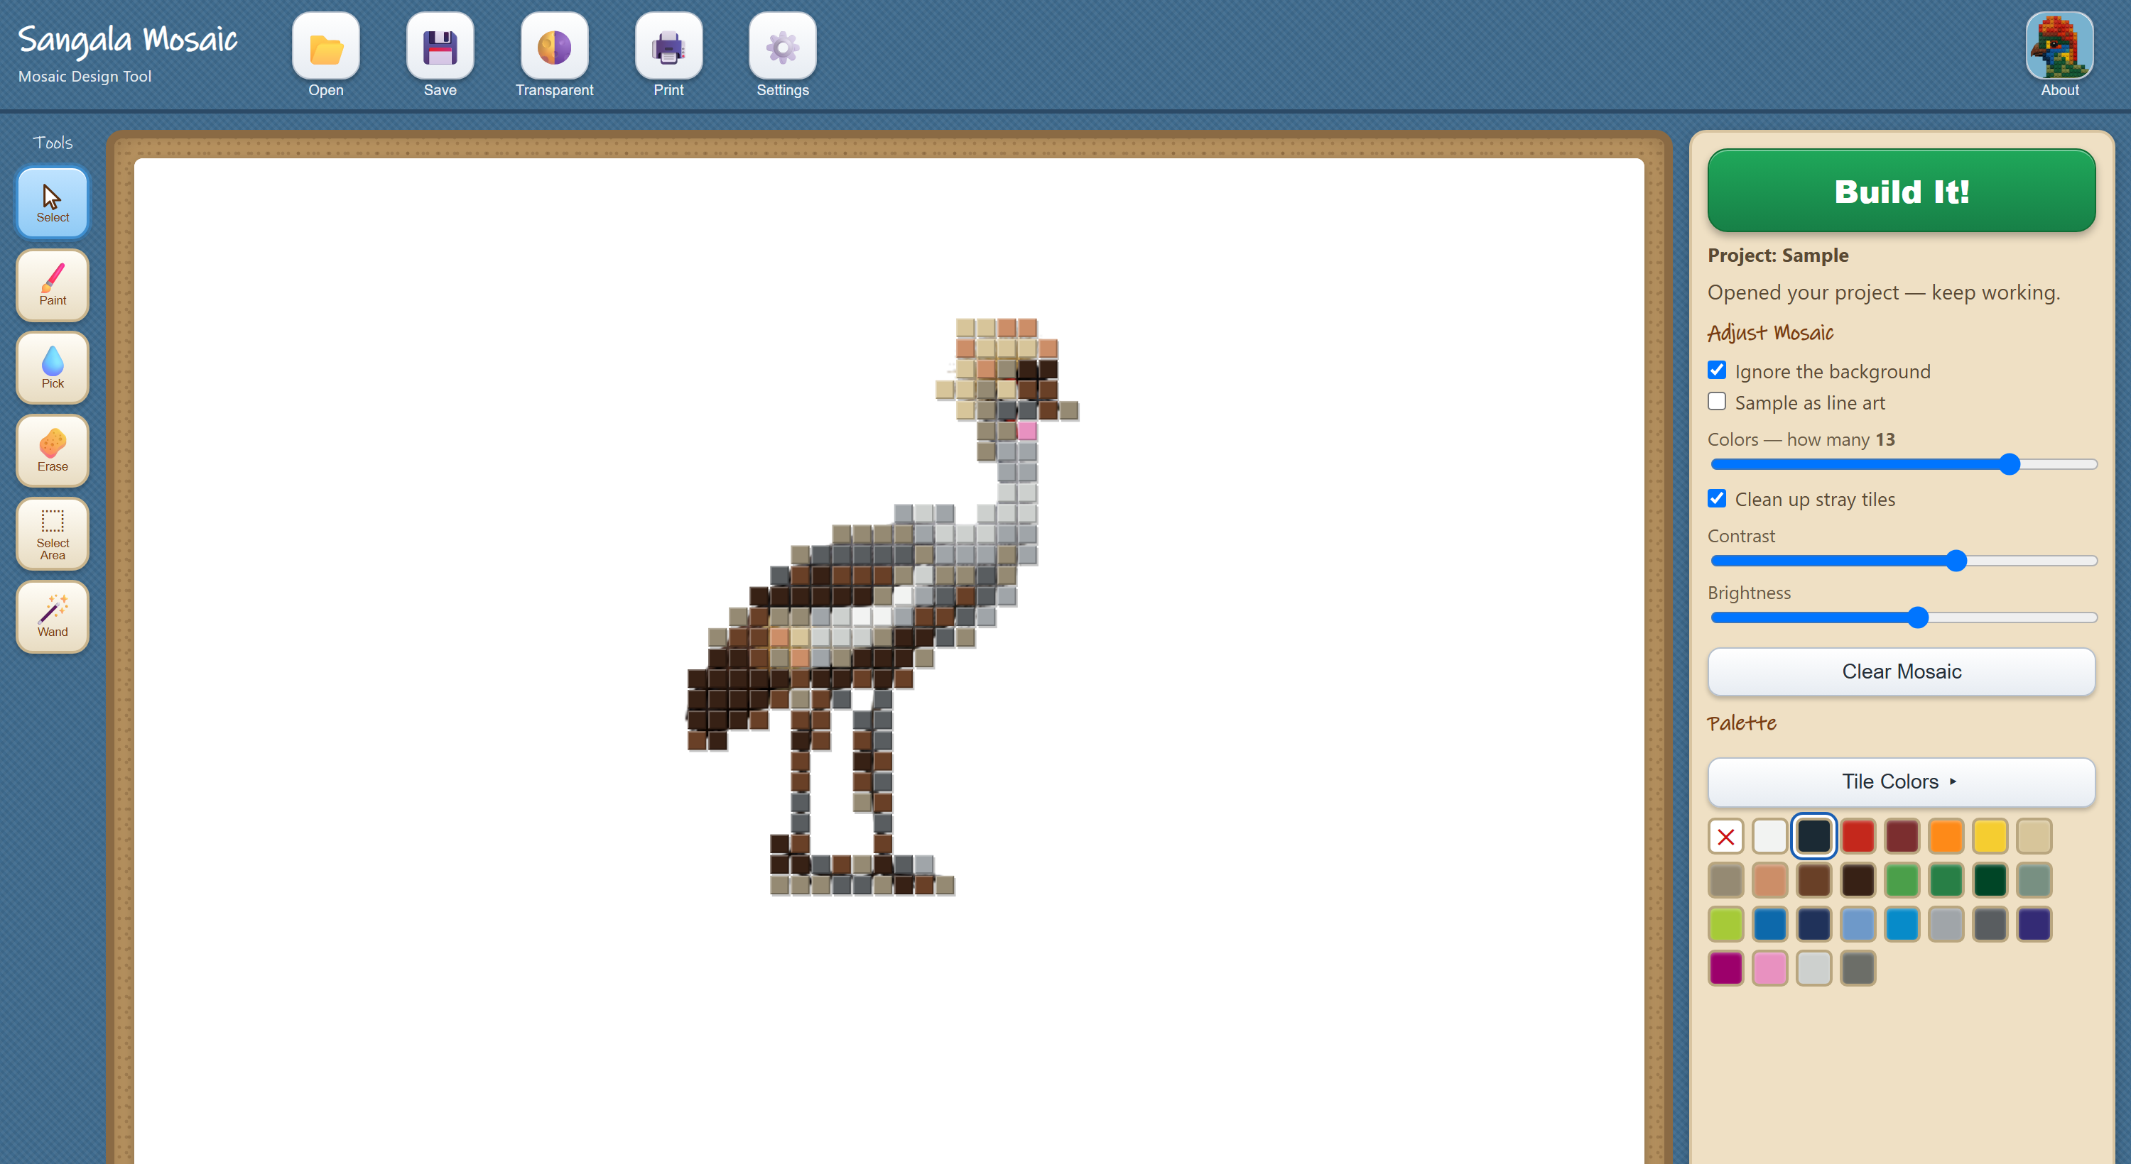
Figure 1. The four regions of the screen: the menu bar, the tools, the workspace, and the build panel.

2. The palette
The mosaic is built from the colors in the palette; the tile list counts how many of each the design uses.
- The palette drives the mosaic. Down the right side is the Palette — real LEGO tile colors, including several grays from very light to dark, so a mostly-gray subject still shows its shading. The mosaic uses only these colors. To change them, press Tile Colors and then Edit: click a color to turn it off or back on. Clear empties the palette so you can add just the colors you want; Reset brings back the standard set.
- The None swatch. First in the palette, a red ✕ — not a color but “no tile.” With tiles or a part selected, clicking it empties them (one undo step); in a painting tool it switches to Erase. It is hidden inside Edit, where none is not a color.
- Add colors from a photo. Add Tile Colors in a Photo (under Tile Colors) reads the LEGO colors out of a photo in the workspace — loose tiles, a tray of them, or a mosaic already built — and adds them to the palette as Custom Tiles, kept beside the Standard Tiles.
- The tile list counts every color. After you build, the status line totals them, and Save → Tile List writes every color with its count — “47 dark gray, 23 white, 8 red…” — the list to order from or build against. The printed sheet carries the same counts beneath the picture.
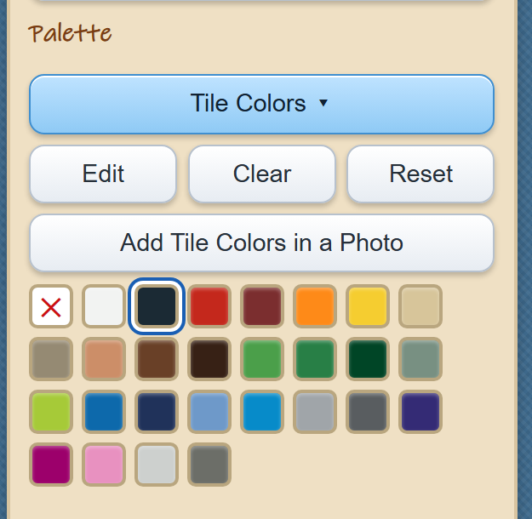
Figure 2. The palette, with Tile Colors open for editing.

3. Open a photo (and build a scene)
- Click Open (or drag a picture onto the workspace). Sangala accepts .png and .jpg.
- The photo drops onto the workspace at a comfortable size. Drag its body to move it; drag a corner handle to resize it (the shape is kept, so it never stretches). Press Delete to remove a selected photo.
- Open again to add another picture. Each Open adds a layer, so you can build a scene — a background behind, a subject in front — and turn the whole composite into one mosaic.
Layer order (which picture is in front). Select a picture to open its panel on the right, then use the layer controls there to send it forward or back, so the foreground animal sits on top of the background.

4. Remove the background
Remove Background clears the backdrop from a picture so that only the subject becomes tiles:
- Select the picture.
- In its panel, turn on Remove Background. Sangala clears the backdrop from the edges inward and leaves the subject — keeping interior whites (a crane's white belly stays; only the true background goes).
- The original is never lost. Turn Remove Background off to bring the backdrop back.
With the background removed, the empty area around the subject becomes empty cells in the mosaic (or bare baseplate), not tiles.

5. The grid — framing the mosaic
The grid frame is the box on the workspace that decides what becomes the mosaic and how fine it is. Whatever falls inside the frame is what gets built.
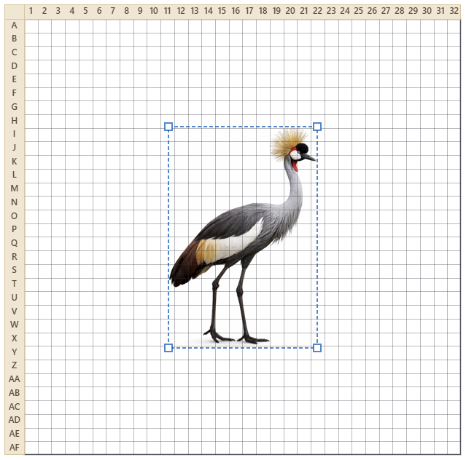
Figure 3. A photo positioned under the grid — whatever falls inside the frame becomes the mosaic.
- Move it — drag the frame's border. Resize it — drag a corner (the cells stay square).
- Fit to Photo — in the Build panel, directly beneath Build It!, one press lays the grid over the photo for you: the largest area of the grid’s shape that fits the picture. Adjust from there if you want a different framing.
- Across and Down — in the Grid Controls section of the panel that opens under Settings, set how many tiles wide and tall. The standard baseplate is 32 × 32, and that is the default. The readout shows the real size — 32 × 32 tiles is about 256 mm square. A new size takes effect when you press Enter or leave the field, not while you are still typing it. If a mosaic is already there, the tiles that still fit are carried across and any that fall outside are counted for you; Ctrl-Z puts the old grid back.
- Show — three checkboxes for what you see on the workspace: Grid (the cell lines and the row and column labels — numbers across the top, letters down the side — that you follow while building), Baseplate (the studded plate behind the tiles), and Box (the outline around the mosaic). Turn any of them off — turn all three off to see just the mosaic itself.
- Key — one checkbox, Number the Tiles, off until you turn it on. Each color then gets a number, printed on every tile of that color, and a key beneath the mosaic names them. The colors run by family and, within a family, from the lightest tone to the darkest, so two that look alike in the hand — the grays, dark blue and black — can be told apart by the number on the chart. The same numbers appear on the printed sheet and in the Tile List.
Fewer tiles across make bigger, blockier tiles and a coarser picture; more make a finer picture that needs more, smaller tiles.

6. Build It!
Press the green Build It! button and Sangala maps the framed picture to your palette colors, cell by cell, and shows the result on its baseplate. Transparent lets you check it against the photo. Building again over a same-size mosaic is one undo step — Ctrl-Z brings the previous mosaic back.
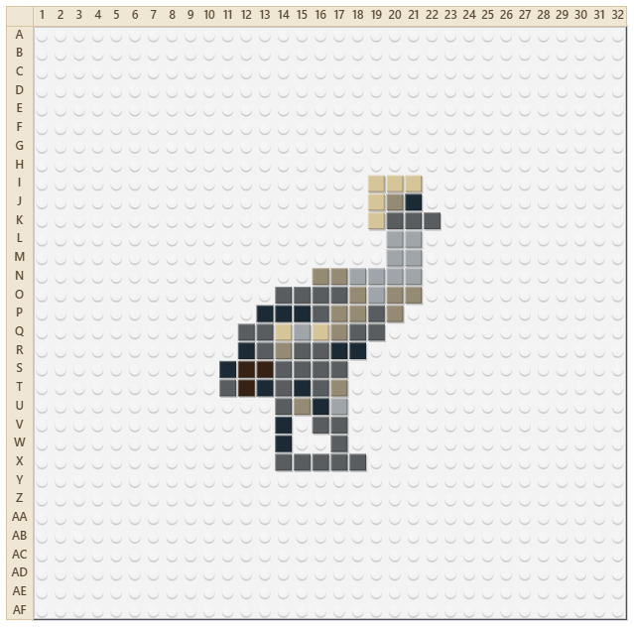
Figure 4. The finished mosaic on its baseplate.
Two controls in Adjust Mosaic set how the photo is mapped, and apply at the next Build It!:
- Ignore the background (on by default) — treats the removed or empty background as empty cells, so thin parts like legs survive instead of being outvoted by a sea of sky.
- Clean up stray tiles — gently fills single-tile holes and drops lone stray tiles, so the mosaic reads cleanly without erasing real detail.
The other three adjust the mosaic as it stands: every filled cell is re-mapped from its own source color — hand-placed tiles included. Filled cells stay filled, empty cells stay empty, and each slider gesture is one undo step:
- Colors — how many different tile colors to reduce the picture to. A low number gives a bolder, simpler mosaic; a high number gives more shading. Sangala always snaps these to the nearest palette colors.
- Contrast and Brightness — shift every filled cell’s color, darker, lighter, or further apart, before it snaps to the nearest palette color.
- Clear Mosaic — empties every cell as one undo step. Photos, palette, grid, and parts stay.
Cells can also be edited one at a time with the hand tools (Section 10).

7. Line art: rendering a drawing
Sample as line art (in Adjust Mosaic) suits a drawing rather than a photograph. Every cell is judged to be line, color, or paper: a cell mostly covered by ink takes Black, a cell carrying color takes that color, and a cell with neither is left empty, so the paper of the drawing becomes bare baseplate. With the setting off, a cell instead takes the average of the pixels beneath it, and a cell straddling an ink line averages ink and paper together into a gray that appears nowhere in the drawing.
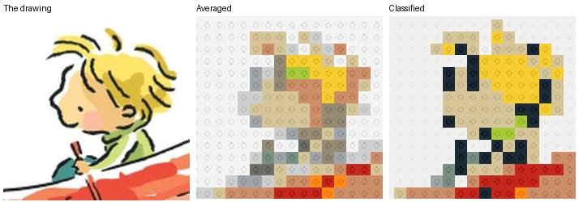
Figure 5. The same drawing averaged, and with Sample as line art on.
The line is drawn in Black. If Black is switched off in the palette, the status line names the color used in its place. Line art works with any medium; in Dots the drawing reads as marks on paper, which is closest to how it was made.
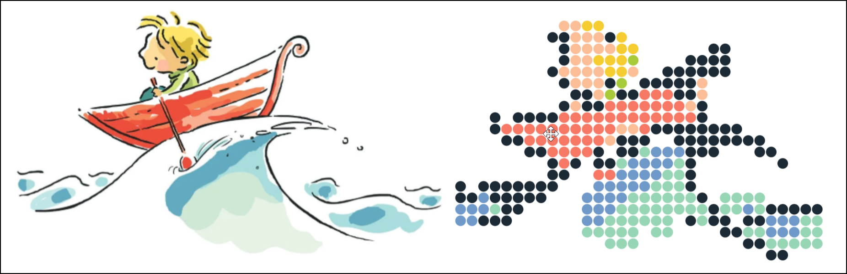
Figure 6. A drawing rendered as dots, beside its source.

8. The medium: tiles, dots, and beads
The built mosaic sits on a baseplate — the studded plate the tiles snap onto — so you see it the way it will really look.
- Baseplate color — choose from the Baseplate swatches in the panel that opens under Settings. These are limited to the colors LEGO actually sells baseplates in (White, Green, Gray, Blue, Sand (Tan), Black, Red, and Light Blue). White is the default.
- Show or hide — the Baseplate checkbox hides the plate for a clean, chart-like view of just the tiles (handy for reading the pattern). With the plate shown, the studs mark the grid; hide it and the cell lines return so empty cells stay clear.
Medium (in Settings) chooses how the mosaic is drawn. Tiles is square LEGO tiles on the studded baseplate; Dots is dot stickers, or marker dots, on poster paper; Beads is round beads on a plain tray. For Dots and Beads the Baseplate color is that surface and shows between the elements; only Tiles has studs, so with Grid on the cell lines show. The palette is named for the medium — Tile Colors, Dot Colors, or Bead Colors — and Dots offers sixteen colors the others do not. The choice carries through the workspace, the saved image, and the printed sheet, and saves with the project.
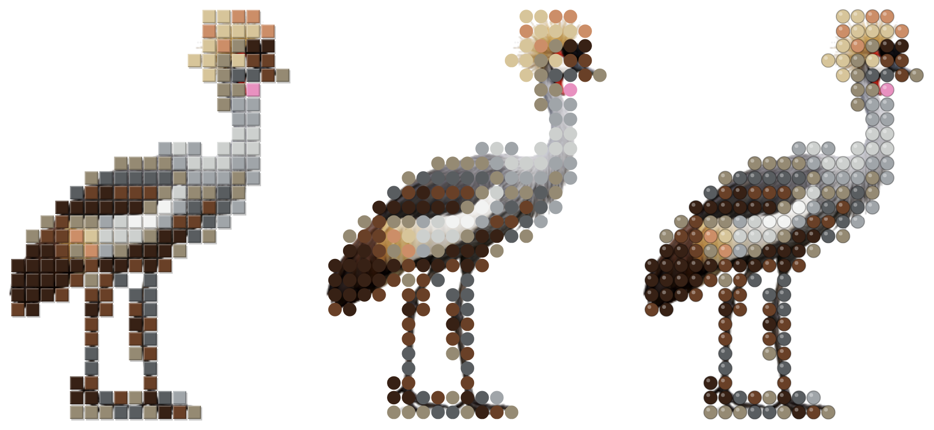
Figure 7. The same mosaic drawn as tiles, as dots, and as beads.

9. Seeing the mosaic
The mosaic sits in the grid, so it is always on screen. Two ways to compare it with the photo:
- Side by side — the workspace stays live, so Open a copy of the photo and drag it beside the mosaic; adding or moving it never disturbs the mosaic.
- Transparent — make the tiles translucent so the photo shows through underneath. It stays available while painting (Section 10). The Transparency slider (in Adjust Mosaic, shown while Transparent is on) sets how much photo shows through; the setting saves with the project.
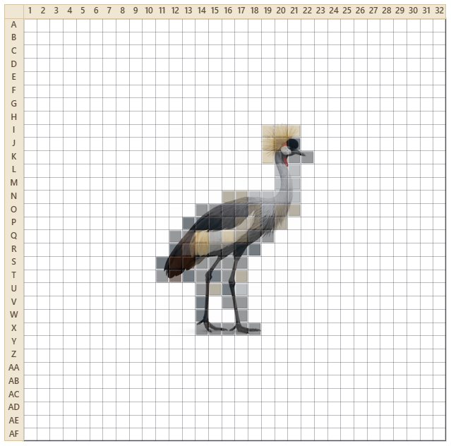
Figure 8. Transparent makes the tiles translucent so the photo shows through.

10. Editing tiles by hand: Paint, Pick, Erase
Three tools on the left rail edit individual cells. They do not wait for a build: choosing one with nothing open starts an empty mosaic at the current grid size, so a design can be drawn tile by tile from the beginning. When to start a mosaic is your decision, not the program's.
- Paint — click a color in the palette, then click or drag across cells to set them to that color. Hold Shift to erase instead, and release it to paint again, so a correction in the middle of a stroke needs no trip back to the tool rail. Right-click a cell to clear it.
- Pick — click a cell to grab its color, then keep painting with it.
- Erase — click or drag to clear cells back to empty (the baseplate shows through).
Undo is there. Ctrl-Z undoes your last stroke — a whole dragged line comes back in one press — and Ctrl-Y (or Ctrl-Shift-Z) redoes it. Changing the grid size is a single step of its own, so that too can be undone. Building again over the photo replaces what is there, as does changing the photo itself.
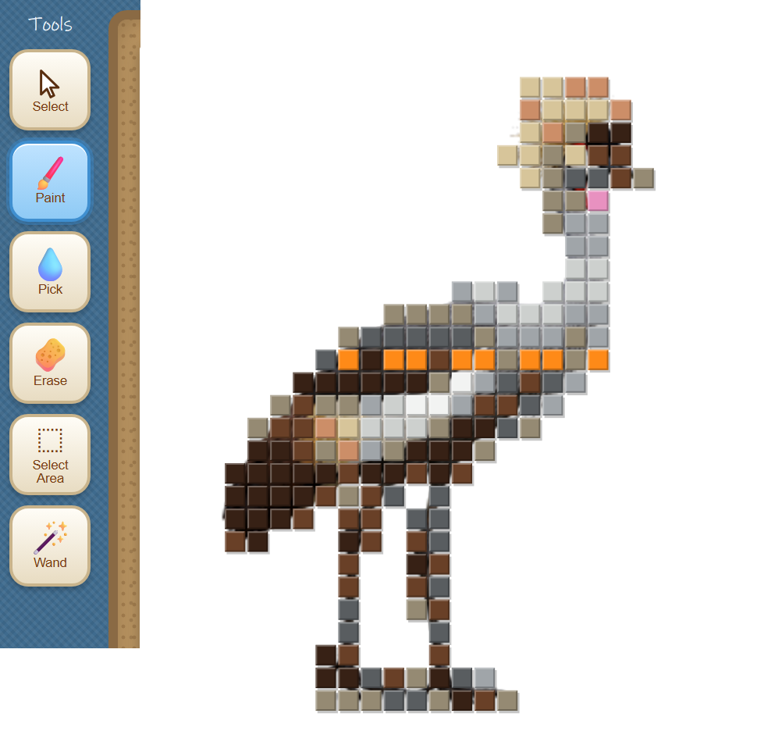
Figure 9. The Paint tool, with a row of tiles painted over the built mosaic by hand.

11. Grouping tiles into parts
Any group of tiles — a head, a leg, any region — can be selected and assigned a name. After a build, select tiles and Group them:
- Select Area — drag a box to select the tiles inside it, whatever color they are.
- Wand — click a tile to select the whole connected run of that color. The Similar Colors slider (shown while the Wand is active) lets nearby colors join the run — at 0, only the exact color; moving it re-grows the last clicked run.
- Shift-click adds or drops a single tile; Alt removes; Ctrl-D deselects. The three selection tools all feed one selection, so mix them freely.
- Group turns the selection into a named part. Select (the arrow) reselects a part with one click; change its tiles and the button reads Update Part — press it to keep the change.
- Move a part — with a part selected, the arrow keys shift it one stud at a time. Its tiles and its outline travel together, so nothing is left behind at the old position, and a run of presses undoes in a single Ctrl-Z. A part stops at the edge of the plate, and it covers whatever it is moved onto.
Parts are saved in the project and keep their names when it is reopened.
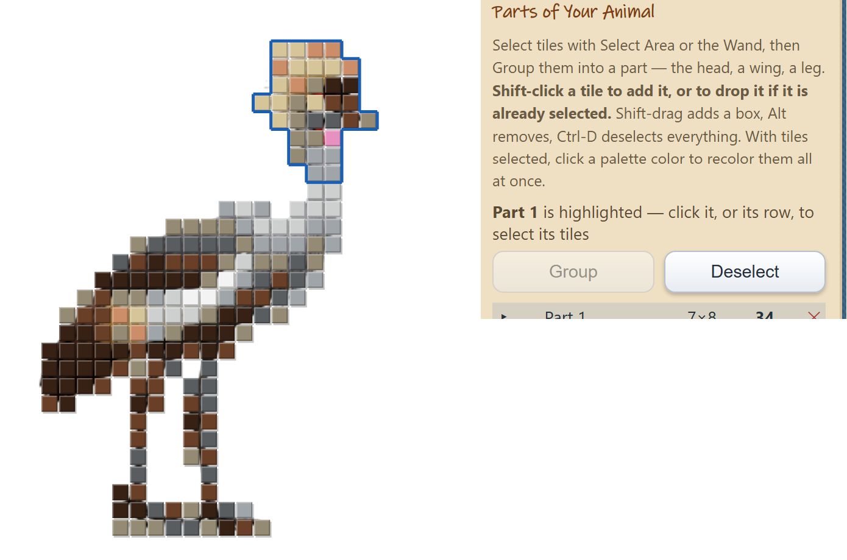
Figure 10. A selection grouped into a part, outlined on the mosaic and listed on the right.

12. The tile list (bill of materials)
After Build It!, the status line gives the headline — how many tiles in how many colors. Save → Tile List writes the full list as a text file: every color with its count, sorted most-used first, and the grand total. Every line begins with that color’s key number, whether or not Number the Tiles is on, so the list and the chart agree. Print puts the same counts beneath the picture on the printed sheet (Section 13). Because Sangala builds only from the palette, every line is a color in it.
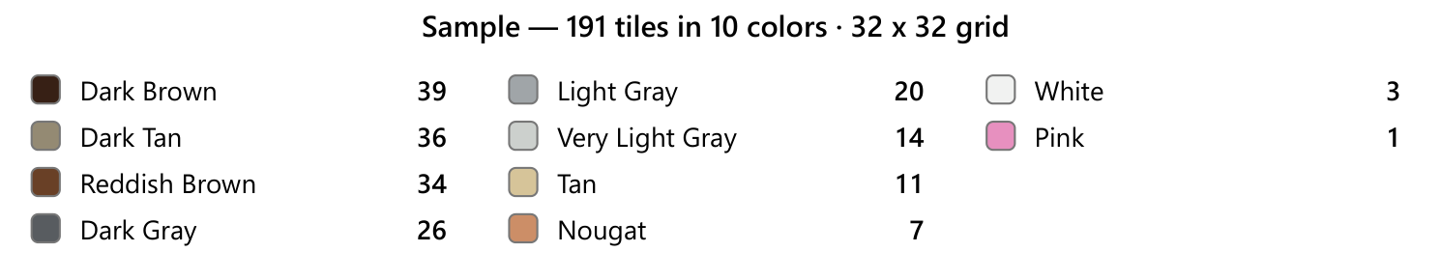
Figure 11. The tile list beneath the printed sheet: every color with the number of tiles the design uses.

13. Saving and printing
Work leaves the tool three ways: as a saved project, as an image or tile list, or as a printed sheet.
- Save your work — the Save button gives a choice. Project saves everything as a .mosaic file — your photos, the grid, your palette, your parts, and the built mosaic — so you can reopen it later and keep editing, and you choose where it goes. Image saves a picture of the mosaic as a .png or .jpg.Tile List saves the tile counts by color as a .txt — the list to order from or build against.
- Reopen a project — the same Open button that opens a photo also reopens a saved .mosaic project, bringing your whole workspace back so you can carry on. The open project’s name shows under Build It! and in the browser tab.
- Print — the Print button prints the mosaic. The saved picture and the printout both follow the Show checkboxes; with Grid on, the printout includes the row and column coordinates. Beneath the picture, the printout lists the tile counts by color, each with its key number.

14. Quick reference
I want to… | Do this
Add a photo | Open, or drag a picture onto the workspace
Move or resize a photo | Drag its body, or a corner handle
Build a scene | Open more pictures; set which is in front with the layer controls
Drop the background | Select the photo, turn on Remove Background
Choose what becomes the mosaic | Drag or resize the grid frame over it
Fit the grid to the photo | Fit to Photo (in the Build panel)
Set the mosaic's size | Across and Down in Settings, under Grid Controls
Choose your palette colors | Tile Colors, then Edit — click colors on or off
Make the mosaic | Build It!
Simplify or add shading | The Colors slider
Change the baseplate | Baseplate swatches; uncheck Baseplate to hide it
Tiles, dots, or beads | Medium (in Settings)
Save your work | Save → Project (.mosaic), Image (.png / .jpg), or Tile List (.txt)
Print the mosaic (or a build chart) | Print — turn on Grid for coordinates
Compare with the photo | Transparent, or drag the photo beside the mosaic
Fix a cell by hand | Paint, Pick, or Erase; Ctrl-Z to undo
Name a group of tiles | Select Area or Wand to select it, then Group
Empty the selected tiles | The ✕ swatch in the palette
Clear the whole grid | Clear Mosaic (Ctrl-Z restores)
Get the tile list | Save → Tile List, or the counts on the printed sheet
Move a part | Select it, then press the arrow keys
Erase while painting | Hold Shift and drag with the Paint tool

